Project Design Phase-II
Data Flow Diagram & User Stories

Date | 31 January 2025
Team ID | LTVIP2026TMIDS65560
Project Name | Educational Organization Using ServiceNow
Maximum Marks | 4 Marks

Data Flow Diagrams:
A Data Flow Diagram (DFD) is a traditional visual representation of the information flows within a system. A neat and clear DFD can depict the right amount of the system requirement graphically. It shows how data enters and leaves the system, what changes the information, and where data is stored.

Example: (Simplified)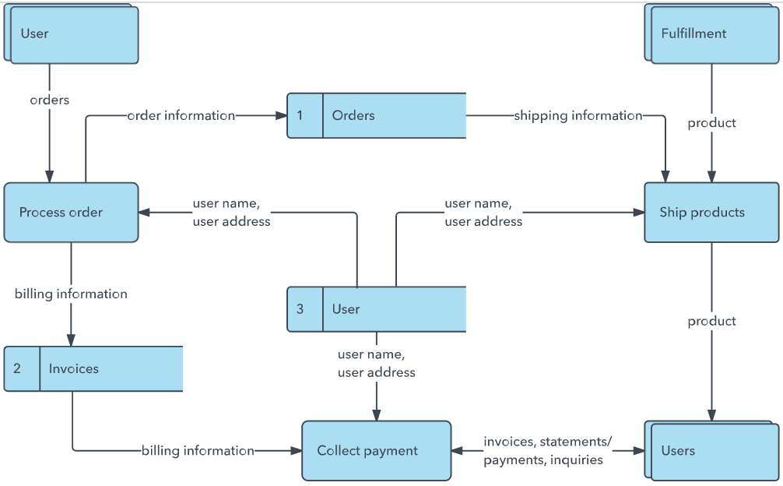
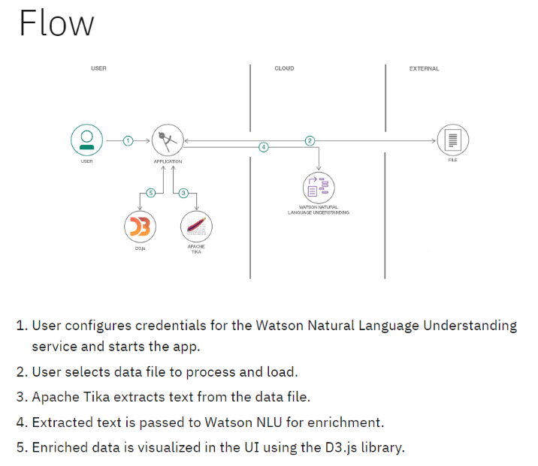

User Stories
Use the below template to list all the user stories for the product.
User Type | Functional Requirement (Epic) | User Story Number | User Story / Task | Acceptance criteria | Priority | Release
Customer (Mobile user) | Registration | USN-1 | As a user, I can register for the application by entering my email, password, and confirming my password. | I can access my account / dashboard | High | Sprint-1
Student | Login | USN-2 | As a user, I will receive confirmation email once I have registered for the application | I can receive confirmation email & click confirm | High | Sprint-1
Student | Dashboard | USN-3 | As a user, I can register for the application through Facebook | I can register & access the dashboard with Facebook Login | Low | Sprint-2
Student | Service Request | USN-4 | As a user, I can register for the application through Gmail | Request submitted and tracked | Medium | Sprint-1
Student | Login | USN-5 | As a user, I can log into the application by entering email & password | Status displayed | High | Sprint-1
Teacher | Dashboard | USN-6 | As a teacher, I can update student performance. | Data updated | High | Sprint-1
Customer (Web user) | Upload Marks | USN-7 | As a teacher, I can upload student marks. | Marks saved successfully | High | Sprint-1
Admin | User Management | USN-8 |  | Users added/removed | High | Sprint-1
  As an admin, I can manage users.
Administrator | Admission Management | USN-9 | As an admin, I can manage admission details. | Admission data stored | High | Sprint-2
Admin |  | USN-10 | As an admin, I can generate reports. | Reports generated | Medium | Sprint-2
  Report Generation

Data Flow Diagram (DFD) - Level 1
Entities:
· Admin – manages setup, data entry, and evaluation
· Student – subject of data entry and academic progress
· System Database – stores and processes all relevant data
Processes:
1. Student Admission – capturing student personal and admission data
2. Student Progress Entry – entering marks and academic progress
3. Result & Grade Generation – calculating totals, percentages, and results
Data Stores:
· D1: Salesforce Table – student personal information
· D2: Admission Table – admission-related data like status
· D3: Student Progress Table – marks, progress, results
Data Flow Summary:
· Admin inputs student details → stored in Salesforce Table
· Admission status tracked → in Admission Table
· Marks entered manually → stored in Student Progress Table
· Scripts calculate total, percentage, and result
· Data displayed in the user interface for admin verification.

